**Experiment 4**

**Aim:** Design a smart phone controlled light system.

**Circuit diagram:**

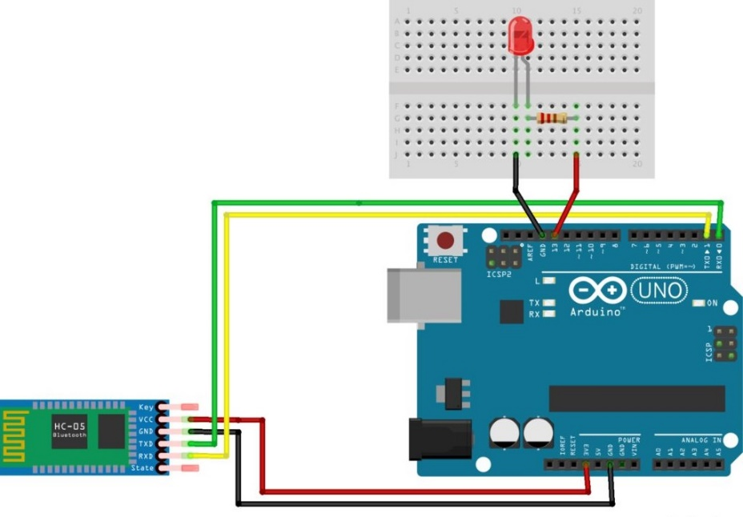

**Theory:**

**CONCEPT USED:**

The android app is designed sending serial data to the Bluetooth module when certain button is pressed. When received data is 1 the LED turns on turns OFF when received data is 0.

1. Working of Arduino UNO
2. Circuitry of Breadboard and it’s use
3. Coding in Arduino IDE and syntax of the same
4. Working of LEDs (Light emitting diodes)
5. Making connections on a Breadboard.
6. Use of Bluetooth.

**LEARNING AND OBSERVATIONS:**

1. Connections in Breadboard and wiring.
2. How to control Arduino and its coding.

Coding is very similar to the coding in C language which we have been taught. I have learnt the importance of delay function as the micro-controller is very capable.

**OBSERVATION:**

1. Blinking of led when controlled with HC-05 Bluetooth module.
2. Relation between software and hardware
3. Connect Arduino to smartphone Wirelessly.

**PROBLEMS & TROUBLESHOOTING:**

1. To select the right port and type of Arduino.
2. To check the loose connections
3. To check the connections according to the codes
4. To check the continuity of the circuit
5. To check the flow of current in the circuit

**PRECAUTIONS:**

1. Handle tools carefully
2. Remove Bluetooth module Tx Rx connection before uploading the program.
3. Do not connect Arduino till the circuit is complete
4. Do not connect LEDs without a variable resistor.

**OUTCOMES:**

1. It is used in transparent wireless serial connection.
2. It is designed to replace serial connections.
3. Connect Arduino to phone wirelessly.